Team Assignments will be ready MONDAY Morning

Do no put yourself in teams

* Office hours
* How does Bro, James communicate with us.
* Things to tell me ASAP!!
* What is happening this week? You have ONE assignment due!!!!
* Steps on the training and team meetings
* How should I set up my Code Topics Portfolio?
* More on Grading
* Team meetings
* Contact with me

# Office hours

**Will be Tues and Thursday at 7PM Central**

You can find me singing my favorite Eagles’ tunes at

<https://byui.zoom.us/my/brojames>

(yes, James is my **last** name)

I will hold a few office hours in the morning. I know some of you only have availability then, so this coming Friday I will be available at 10 A.M. Central.

I hold office hours for the first 3 or 4 weeks of the class. After that you quit showing up and I start dropping by your team meetings occasionally.

The link below is a folder I have on my Google drive it has a variety of files I have collected that present the topics covered in the class. There is actually too much information but it will provide some help now and then. These are good references but there is a lot more out there to use. And I suspect some of it is dated.

<https://drive.google.com/drive/folders/11Zl7cdCdnwg27lZb0iXlr5crOpQyfblZ?usp=sharing>

# How I do communicate to all y’all

* When I can, I like to bullet point things. I **try** not to be verbose. Occasionally you’ll find that hard to believe. Like today; this will be longer than usual. But I will try to keep things concise to not waste your time or confuse you.
* I will **post** all announcements to the **Announcements** section of the class. Here you see Announcements on the left side navigation. Click the link, boom you see the class announcements!

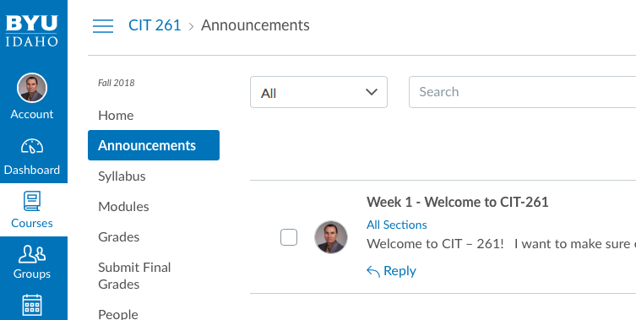

## Things to tell me ASAP!!

* + - * If you are planning on dropping the course. Rather than just not participating with your teams. I want to make the team changes early in the research/training period of the course. If a team gets too small I may need to move people around and the earlier I know that the better
* If you have serious scheduling problems. I want the teams as stable as possible as early as possible. So, if you cannot find a compatible time to meet consistently let me know by the end of this week. I will make some changes as necessary. Your happy cooperation would be appreciated ☺.
* Team meetings need to be recorded. This helps team members that missed a meeting or for me to just check on progress. Google+ Communities and Hangouts-On-Air (HoA) work great for that. Unless you have something better HoA lets you **record** meetings and posts questions back and forth to each other.
* Invite me to you Google+ Community – use my Gmail address [**gtjames@gmail.com**](mailto:gtjames@gmail.com) only for this. Otherwise email me at jamesga@byui.edu

What is happening in week 2? **You have ONE assignment due!!**

* M your team. **First team meeting** (See Syllabus for setup details):
  + Exchange contact information with your team.
  + Identify the times you will meet regularly with your team in the weeks ahead.
  + Create a schedule for teaching for the next 9 weeks (Weeks 2 – 10). (See Week 2 W02 Assignment: Personal and Team Plan) You will have about 5-7 members in a team. Each week you will probably have 3 or 4 people teaching one of the Code Topics. For instance:
    - Week 2 Alice–JSON, Bob–AJAX, Carl–JavaScript
    - Week 3 Don–LocalStorage, Earl–CSS3 Transitions, Alice–AJAX again
    - Week 4 Bob–CSS3 Animations, Carl–Local Storage, Don–JSON again
    - Week 5 so on and so on for weeks 5, 6 and through 10
* Your assignment!! Fill out the spreadsheet found in W02 Assignment: Personal and Team Plan. There are two sections.
  + **The teaching schedule for the team.** Sign up to teach 4 topics. If you only sign up for 2 teaching slots I will ask you “Like, how will you get full points on team participation with only 2 or 3 times teaching?” and your response will be “Like, I guess I won’t get full points” and I will say “Hey! Like, you code sign up to teach more” and you will say “Hey! That is a great idea!”.
  + Yes, everyone will turn in the same thing individually.
  + Y**our personal schedule.** When you HOPE to turn in code (you don’t fail if you don’t keep to the schedule, but you should TRY to stick to the schedule).
* **Second team meeting** – This will be the type of meeting you will have for the next 9 weeks: Several team members teaching their assigned topic for the week. I will post some **sample** teaching videos shortly.
  + Make meetings a recurring meeting so I know (and y’all know) when you’ll be meeting. I like to drop in when I can. If I only get a warning the day of the meeting I can’t always make it. Send me the invites and then y’all will show up on my calendar and I will come by every few weeks for a live Q&A with your team.
  + Here is a very basic training example. It is a little longer than I like. https://youtu.be/I9lw8sLAnpo.

# Steps on the training and team meetings

1. Step 1: Select at least 4 topics and the weeks you will teach in weeks 2-9.
2. Step 2: Prepare for your teaching assignment.
   1. Research the topic
   2. Create a handout/PowerPoint/Word doc to share with the team that explains how to do your assigned topics.
   3. Create a web page that demonstrates the code in a simple manner.
3. Step 3: Present your findings to your team. Walk them through what you learned. Take 10 -12 minutes tops! **Demonstrate your code** by showing your web page and examining the code with them.
4. Step 4: Answer questions from the team. If you do not know the answers then the person teaching that topic the next time has a great starting point for their research and presentation when it is their turn.

* How do I turn in this assignment? Go to **Assignments.** Find the specific Fluency Evident for *Code Topics* (HTML5, JSON, CSS Animations, …) and enter a note telling me

“Bro. James

* + - This is how my code works.” (tell me if I need to enter anything special. Assume I did not write your code.
    - Tell me the browser you tested it on (You DID test your code, didn’t you?!?). I don’t expect it to run on all browsers. If it does not work I will rarely debug your code. That is your job. Have someone else check it out perhaps to make sure. Don’t waste your time submitting something that does not work.
* 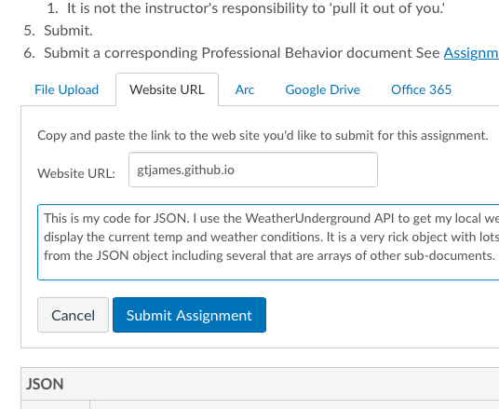
* Above is a sample
* I will NOT look at your JavaScript or HTML files to grade them without first seeing the code working on a web site.
* I will grade the topic and leave feedback. I will always leave feedback

# How should I set up my Code Topics Portfolio?

I STRONGLY suggest (Remember in your last Stake or Ward conference when the Stake Pres. or Bishop said ‘I strongly suggest you live the law of chastity’.... I strongly suggest in the same way that you create a simple index page something like this:

My Portfolio for CIT 261

**Code Topics Last Updated Notes to Bro. James**

JavaScript May 18 first attempt. please review

JSON nothing yet

Local Storage May 25 graded previously Basic

DOM June 2 last grade: Working

CSS3 Transitions not ready

CSS3 Transformations

CSS3 Animations

CSS3+JavaScript

AJAX

JavaScript Events

This is just a for instance. The idea is to allow me to help you as you progress in your understanding of the topics. It allows me to very quickly see how you are doing. As you develop your understanding of these topics you will add a page link that shows me (and your team) what you have learned for that topic. Your examples will start off very simple. But then over the weeks ahead as you learn more you will add complexity to your code topics.

# More on Grading

I will enter scores and comments in Canvas as you submit your code topics. You will get several kinds of scores from me

NOTHING Either you have not submitted anything yet or you copied code form W3Schools and made no attempt to improve upon it.

BASIC You copied code from W3Schools and made changes. You experimented with it and tried variations. You took ownership of what you found and added or changed it to make it your own. Your AJAX request returned a JDON file from a server. Your JSON object included MORE than a name field and an age field. Your CSS bounced a box around the screen while the color changed. You saved a robus JSON object to LocalStorage.

WORKING You showed a good range of examples. Your JSON object included arrays and sub-records. Your AJAX used a third-party API service to return a complex data set in a JSON file. You had a JSON object with an array of sub-records. You saved multiple entries to LocalStorage, retrieved a particular record and displayed it on the screen, then removed it from LocalStorage.

SKILLED You combined several topics together. Using a topic in isolation is not how you use code in the real world. Use a third-party API to get tomorrow’s weather, save each day to LocalStorage, put today’s weather on your web page and use CSS to transition the background color for bright sunny to cold and rainy colors. That shows me you have learned how to make things happen for a purpose

# Teach Topics multiple times -

There should be 3 or 4 topics taught each week. You definitely want to have topics repeated. The first time someone teaches Local Storage or AJAX they will just be discovering it themselves and there are several layers to it that would probably be best absorbed over multiple exposures to it. Some topics need to be covered just once (like JavaScript syntax). You decide which ones need multiple coverage.

# Contact with me

Please email me at [jamesga@byui.edu](mailto:jamesga@byui.edu) with your questions and concerns. I will attend your team meetings every 2-3 weeks and answer any questions you have. Questions of a general nature that you have, I cover in my weekly messages to help the class out as a whole.

That is more than I usually like include in the weekly emails. But week two is a busy one and I do like to help you get in a pattern on your team meetings. Since this pattern stays the same for the next nine weeks.

That is all for now. I will follow with a bit more later this week after the teams have a chance to meet and get to know each other.

If you made it this far your anxiety is probably pretty high. Don’t worry you will be comfortable with this soon enough. And I will attend meetings as frequently as possible.

May the good code me yours. Take a deep breath you are going to do fine!

Bro. James

Here this will help you relax. Dog on a plane with a bow tie. How great is this!?!?

